1. First Load Page

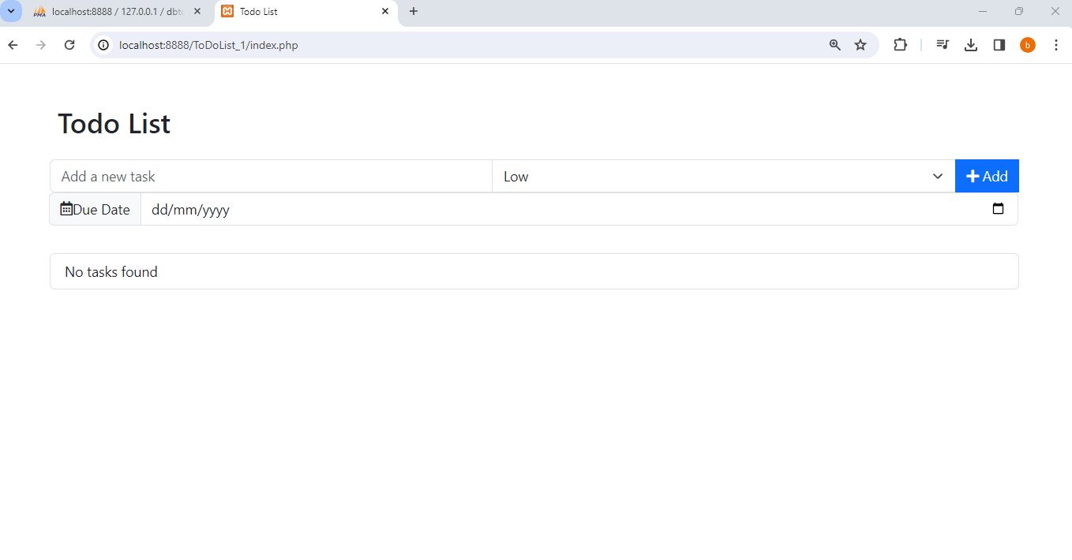

1. Add Task with low Priority.

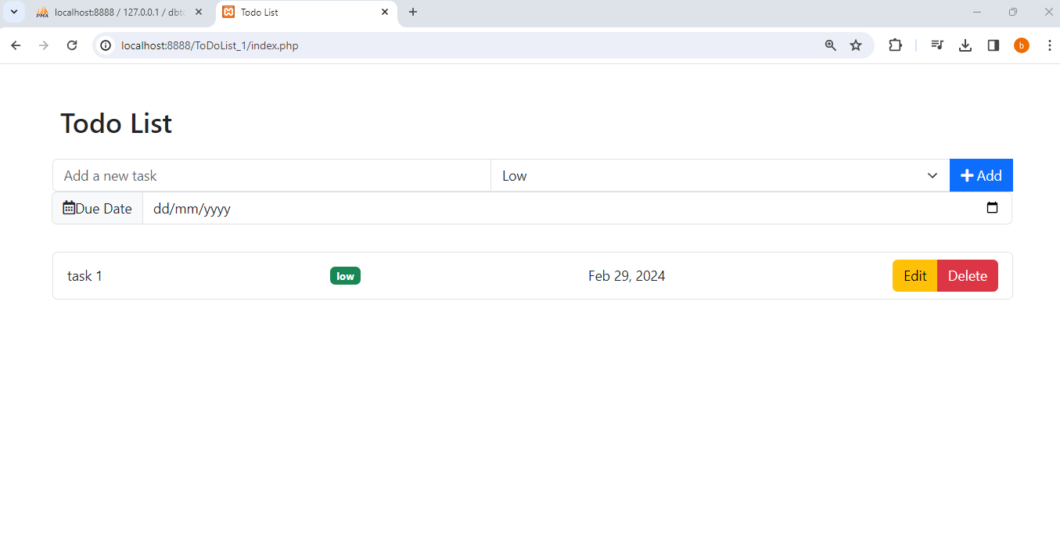

Entry in Db

Tasks with different Priority

All Entry in DB

Edit task

Edited from task 1 to rename task11 and also changed its priority to medium

Verity changes in DB

DELETE TASK

VERITY DELETED TASK IN DB

CHECK FOR VALIDATION

